The Periscope Case Turns Every Phone into an Action Camera, Allowing Users to Capture Images Like Never Before
Press Release

March 7, 2018, Portland, OR- The Periscope Case, the revolutionary new phone case from Defox that turns smartphones into action cameras, is live on global crowdfunding platform Crowd Supply and raising funds to bring the project to life.
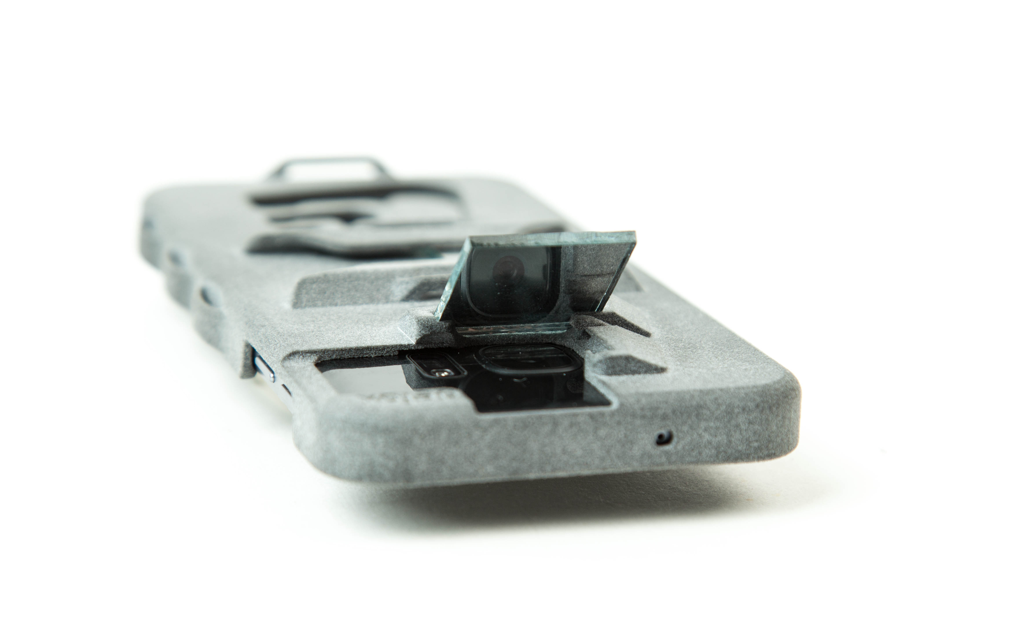
Dubbed the “Working Man’s Go Pro,” by the company, Periscope Case allows the use of your current cell phone for active photography. No longer is expensive camera equipment necessary to capture great shots. Slim enough to fit in a pocket, the Periscope Case turns smartphones into convenient action cameras.

“The inspiration came when I tried to live stream a crawlspace inspection of my house by strapping a smart phone to an RC Car,” says Trevor deVos, founder of Defox. “Getting it secured and at the right angle was impossible. A correctly angled mirror and some zip ties did the trick and I didn’t have to go under myself!”

To use the Periscope Case, users simply need to hold, stand, or strap the phone at a convenient angle, then use the mirror to point the camera in the desired direction. It also serves as an everyday protective case, meaning it's always there when the need arises.

Defox is excited to have one of the first products designed to utilize the new Jet Fusion 3D Printer by HP. The entire case is 3D Printed as one solid part, adding to longevity and simplicity. 3D Printing allows the company to print the case, the loops, the grips, and the mirror latches as one solid part. This simplifies assembly and reduces potential fail points. Most importantly though, 3D Printing enables Defox to apply their patent pending design to a large portfolio of phones and simply print as many as there is demand for. Everything is designed, manufactured, and packaged in the United States.

The Defox Periscope Case is currently live and available for pre-order on Crowd Supply: ***www.crowdsupply.com/defox/periscope-case****

Early bird price: $28
Funding Goal: $1,500
Campaign End: 4/20/18

